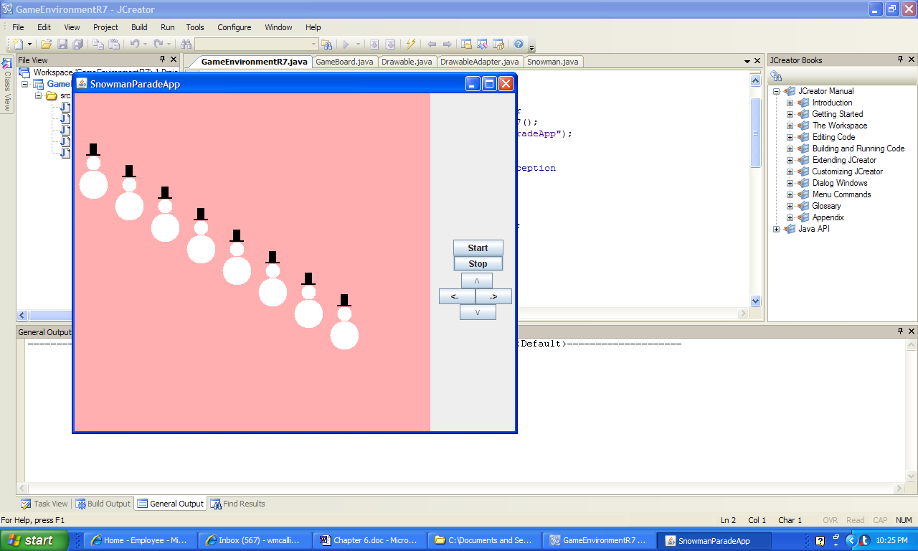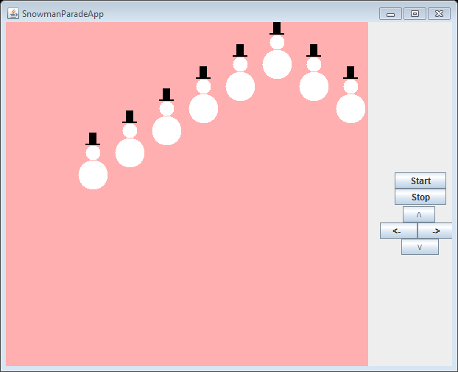

**a) Initial Output b) Output After Several Reflections**

**Figure 6.15 The graphical output of the application PassingArrays.**